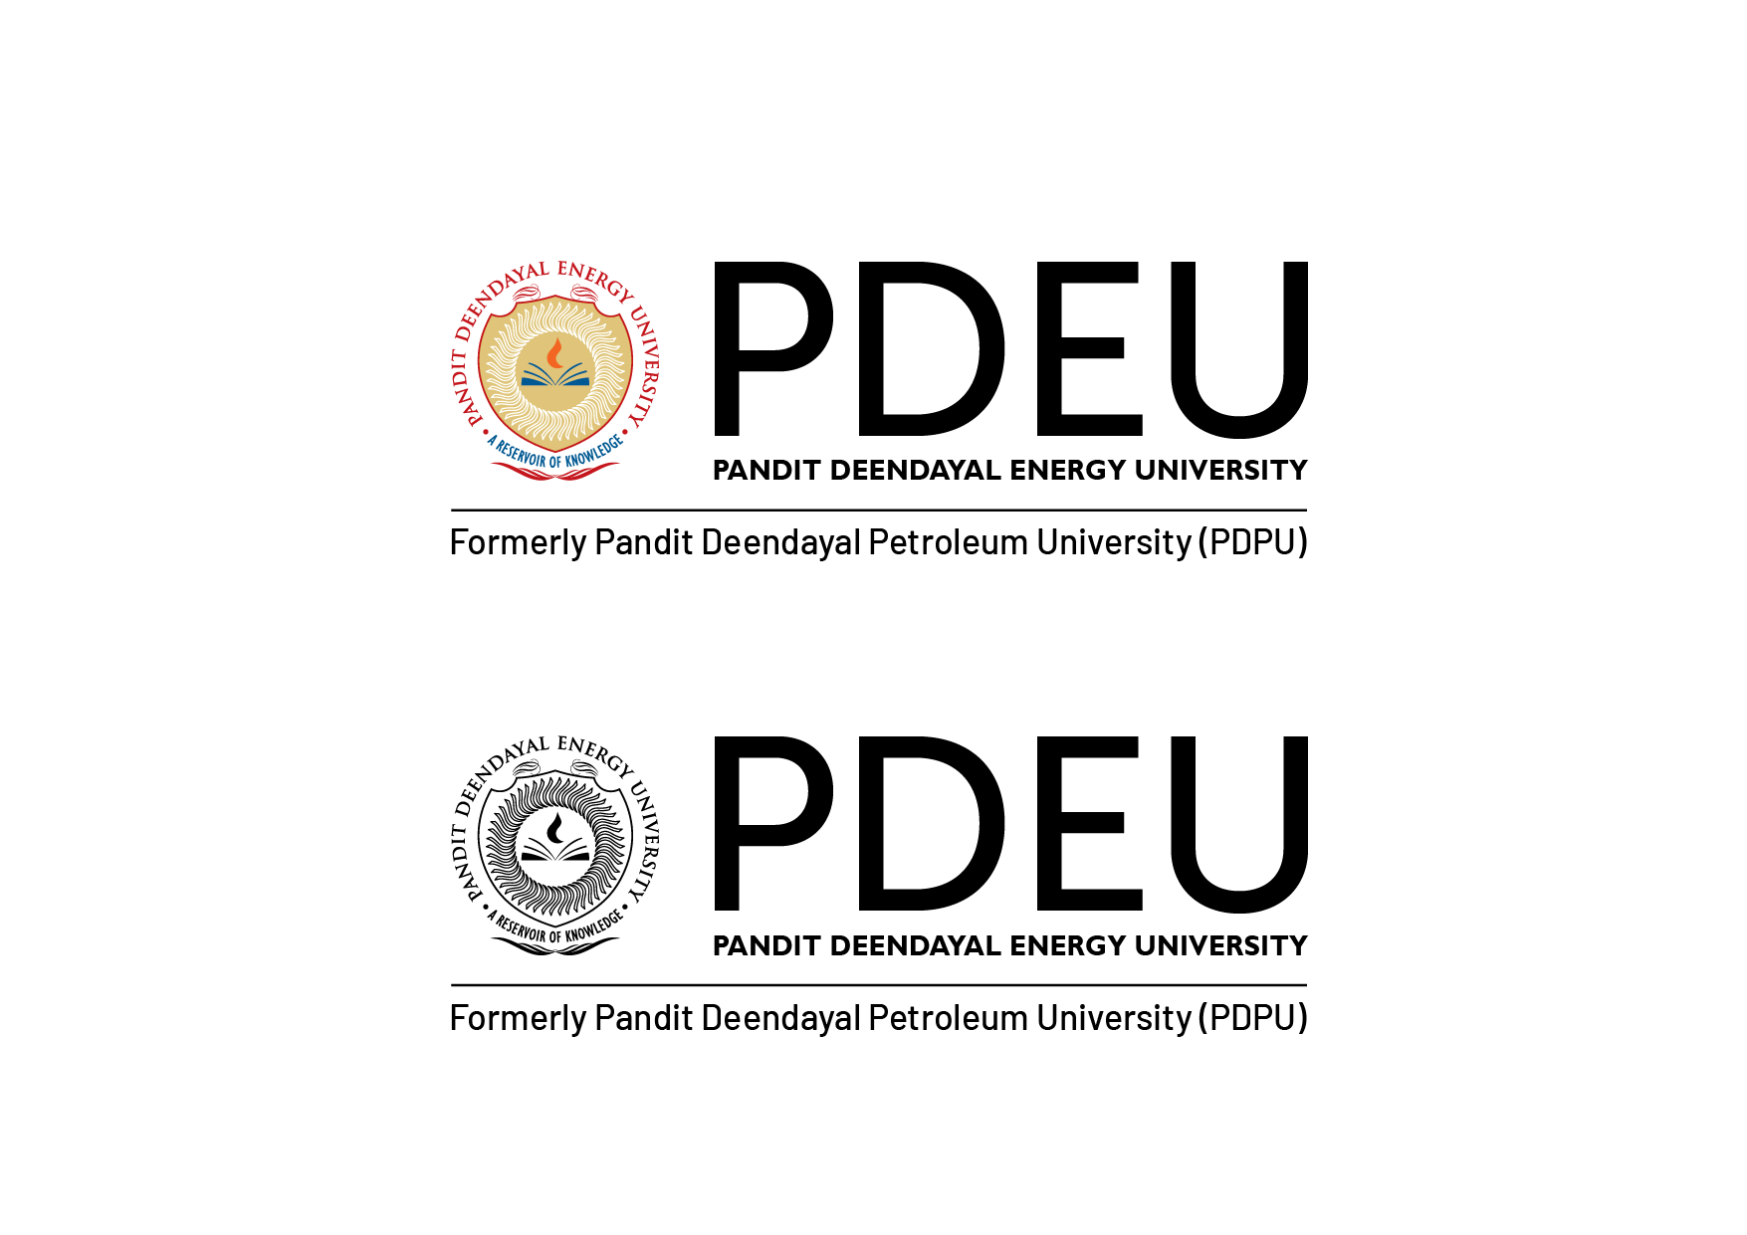
(Student Name)
(School Name)
Pandit Deendayal Energy University
Gandhinagar, Gujarat

E-Mail Id:
Cell No:
Objective

In pursuit of challenging assignments that would facilitate the maximum utilization and application of my skills and expertise in making a positive difference to the organization.
Education Qualification

Qualification | Institute | Board / University | Year Of Passing | CPI
B.Tech (Branch) | (School Name) | Pandit Deendayal Energy University | 2010 | 7.00
12th / Diploma |  |  | 2006 | 75.00%
10th |  |  | 2004 | 75.50%
Industrial Orientation / Internship

Organization Name: Hindustan Petroleum Corporation Limited Duration: Apr 8 – Jun 7 2013
Brief of Visit / Internship:
Co-curricular Achievements and Trainings

- Android Certification
- Unity Certification
- Assistant trainer in bootcamp on Python at Royal Technosoft Pvt Ltd
- Conducted a complete coaching program on C programming language to the students from different states of India as well as from UK.
Extra Curricular Achievements

- Winner of Chess POCC
- IIM as Captain
- Captain in Energy Cup (upcoming)
Personal Information

Name
Languages Known | ENGLISH, HINDI, TAMIL
Permanent Address

Information provided above is true to the best of my knowledge.

Place - Gandhinagar, Gujarat Name -

